SQL Assignment – Observations

1. DISTINCT VALUES
Observation:
- DISTINCT keyword was used to retrieve only unique salary values from the Employees table.
- Duplicate salary values were removed from the result.

2. ALIAS (AS)
Observation:
- Column aliases were used to rename age as Employee_Age and salary as Employee_Salary.
- Aliases make the output more readable and understandable.

3. WHERE CLAUSE & OPERATORS
Observation 1:
- The WHERE clause was used to filter employees whose salary is greater than ₹50,000 and who were hired before 2016-01-01.
- Only employees satisfying both conditions were displayed.
Observation 2:
- Missing designation values were identified and replaced with Data Scientist.
- This helped to handle missing data in the designation column.

Sorting and Grouping Data

4. ORDER BY
Observation:
- Employees were sorted first by Department ID in ascending order and then by Salary in descending order.
- This makes it easy to compare higher-paid employees within each department.

5. LIMIT
Observation:
- The LIMIT clause was used to display only the first 5 employees hired in 2018.
- This helps to restrict the number of records displayed.

6. AGGREGATE FUNCTIONS
Observation 1 – SUM:
- The SUM function was used to calculate the total salary of employees in the Finance department.
- It provides the overall salary expenditure for that department.
Observation 2 – MIN:
- The MIN function was used to find the minimum age among all employees.
- It identifies the youngest employee age in the dataset.

7. GROUP BY
Observation 1:
- GROUP BY was used to calculate the maximum salary for each location.
- This helps compare the highest salary across different locations.
Observation 2 – Analyst designation:
- The data was grouped based on designations containing the word “Analyst”.
- The average salary was calculated for each matching designation.

8. HAVING
Observation 1:
- The HAVING clause was used to identify departments having less than 3 employees.
- It filters grouped results based on the number of employees.
Observation 2:
- Locations having female employees with an average age below 30 were identified.
- HAVING was used to filter the grouped results based on the average age.

JOIN OPERATIONS

9. INNER JOIN
Observation:
- INNER JOIN was used to combine employee and department information.
- It displays employees who are assigned to a department along with their designation and department name.

10. LEFT JOIN
Observation:
- LEFT JOIN was used to display all departments, including departments with no employees.
- Departments without employees show NULL values for employee-related columns.

11. RIGHT JOIN
Observation:
- RIGHT JOIN was used to display all locations along with employees assigned to them.
- Locations without employees are also included, with NULL for the employee name.

12. CROSS JOIN
Observation:
- CROSS JOIN was used to generate all possible combinations of departments and locations.
- Each department is combined with every location.

13. SELF JOIN
Observation:
- SELF JOIN was used to identify pairs of employees working in the same department.
- Self-pairs were excluded from the result.

🪟 WINDOW FUNCTIONS

14. RANK()
Observation:
- The RANK() window function was used to rank employees based on their salary.
- Employees with higher salaries receive better ranks, and employees with equal salaries receive the same rank.

15. DENSE_RANK()
Observation:
- DENSE_RANK() was used to rank employees based on salary within each department.
- Employees with the same salary receive the same rank, without gaps in the ranking sequence.
Overall Observation:
SQL clauses, operators, aggregate functions, grouping, sorting, joins and window functions were successfully used to retrieve, filter, organize and analyze employee data. These queries helped in understanding employee salaries, departments, locations, designations and employee rankings efficiently.

SCREEN SHOT 1
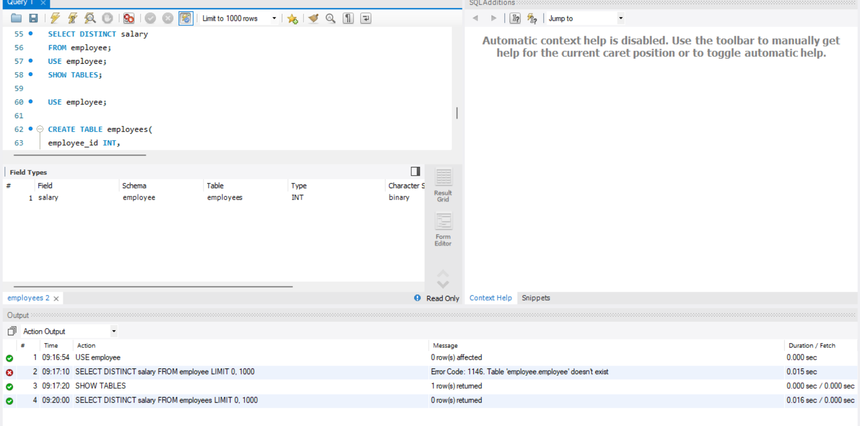

SCREEN SHOT 2
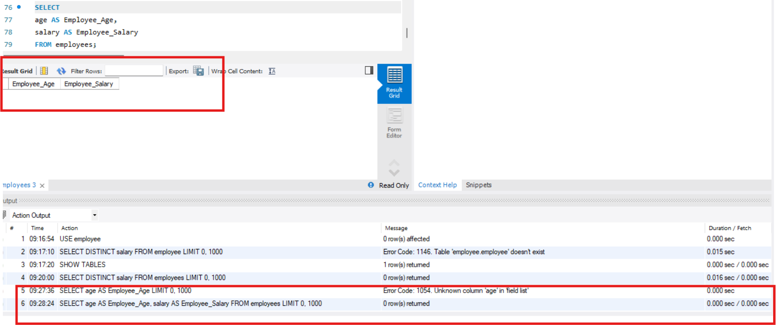

SCREEN SHOT 3
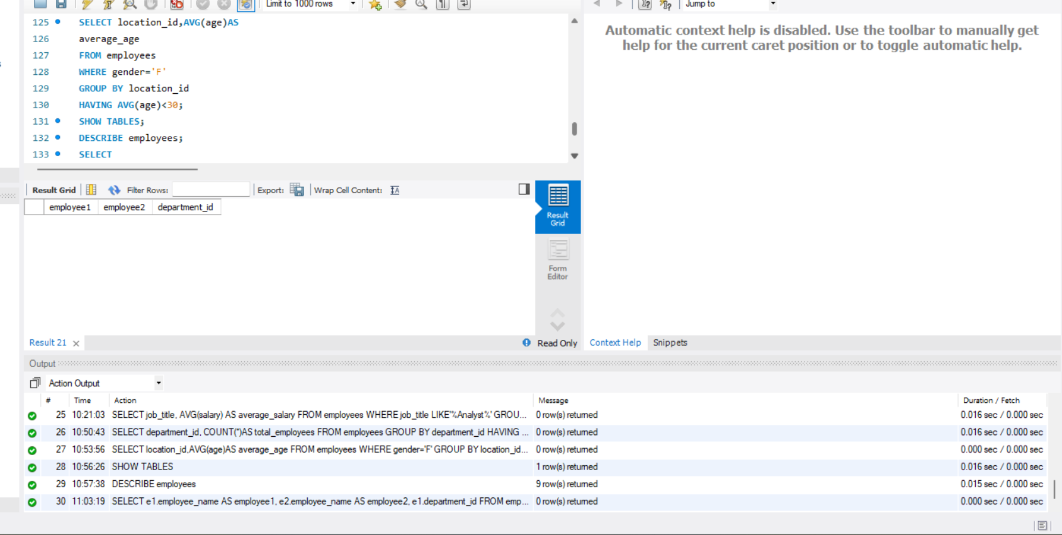

SCREEN SHOT 4
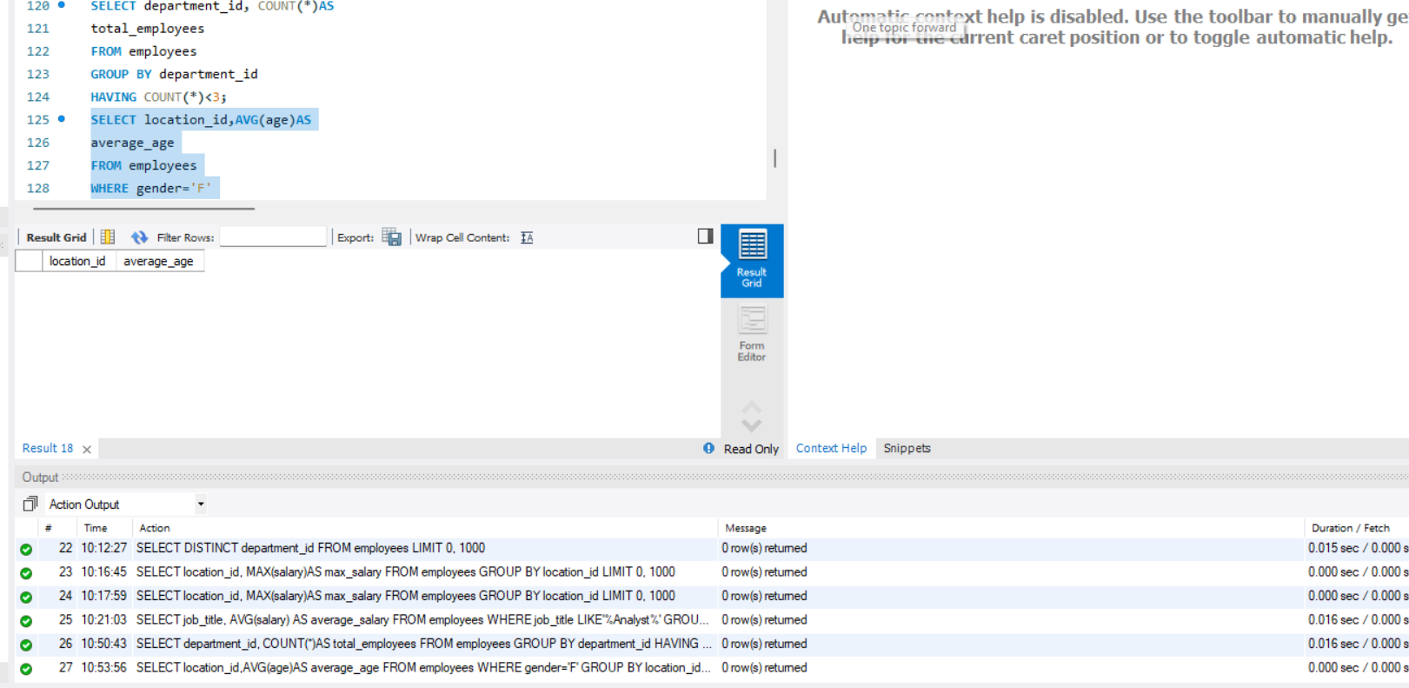

SCREEN SHOT 5
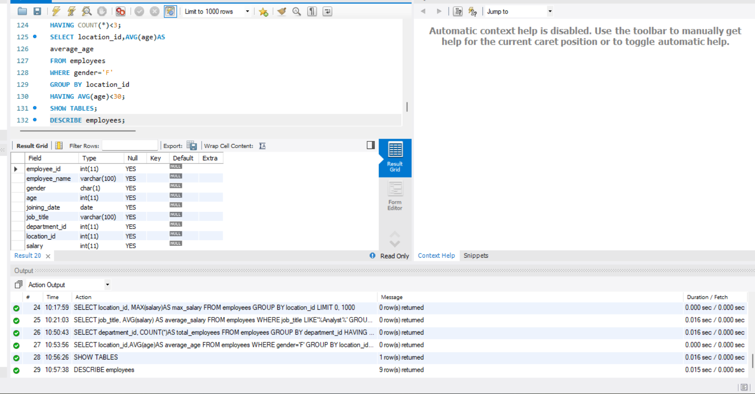

SCREEN SHOT 6
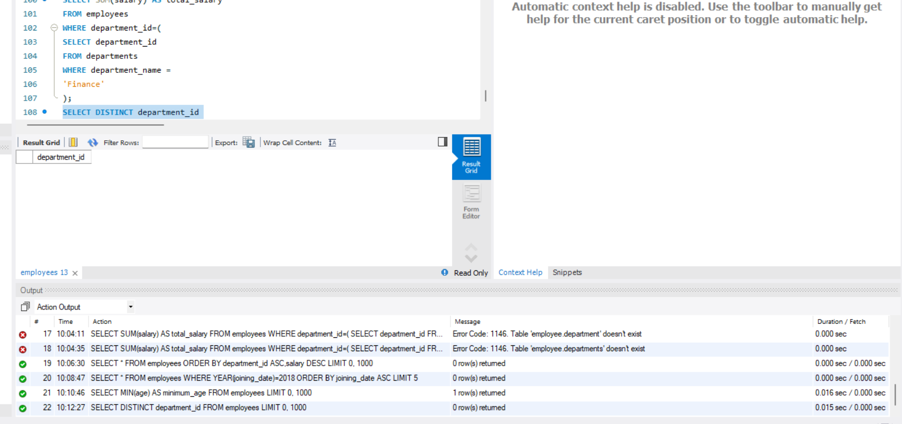
SCREEN SHOT 7
